Christopher Haerle

CS-340 Client/Server Development

Southern New Hampshire University

2/26/2022

Read Me

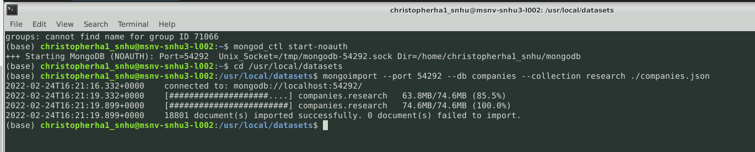

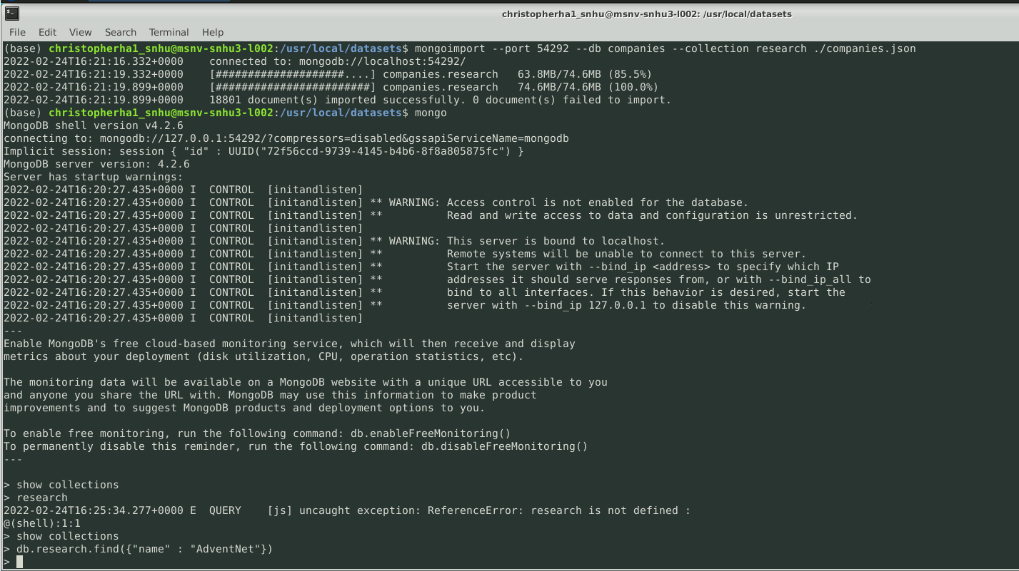

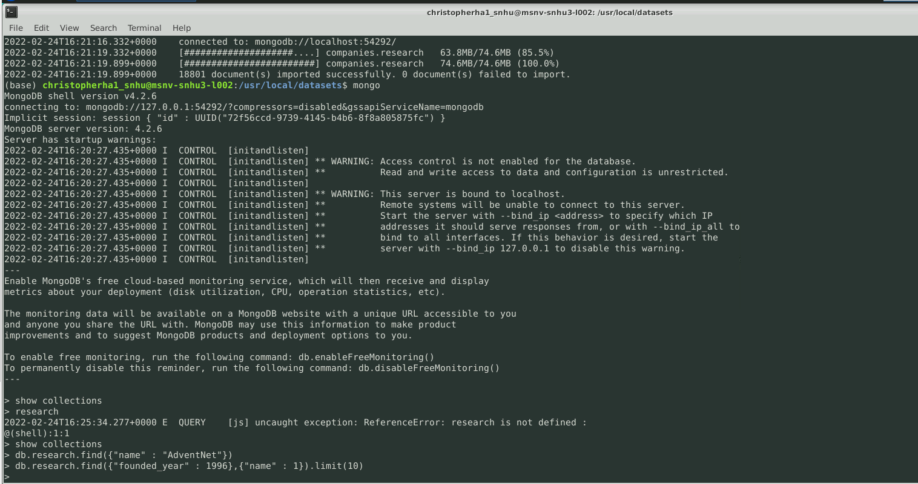

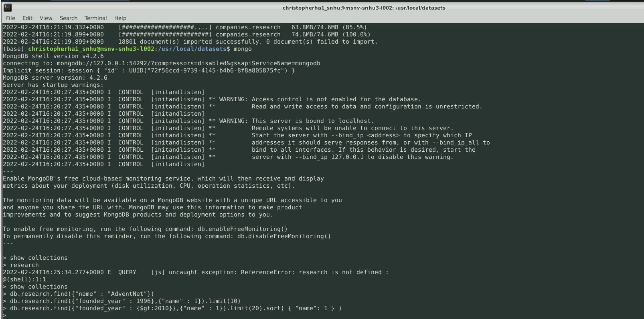

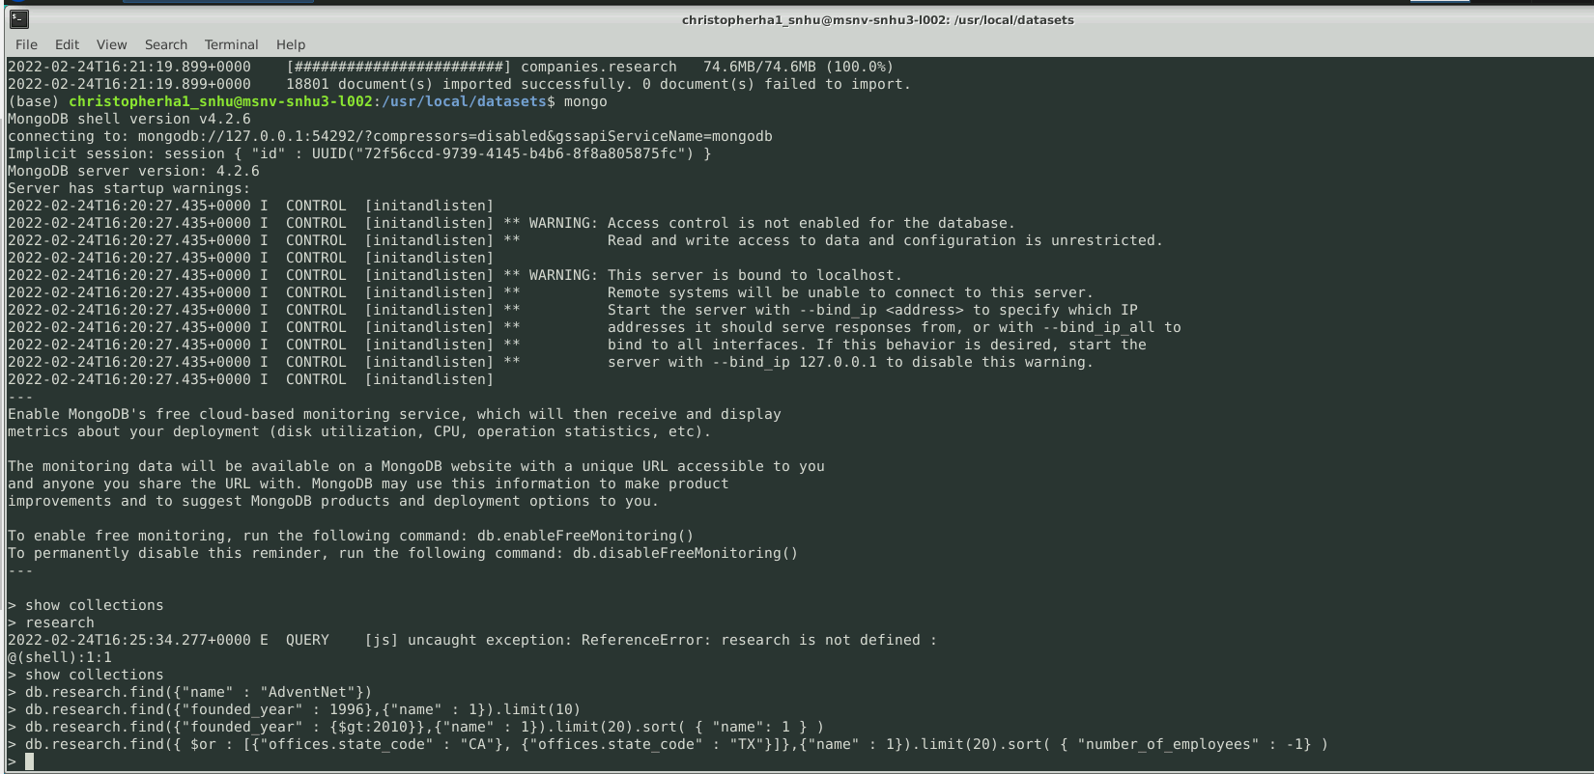

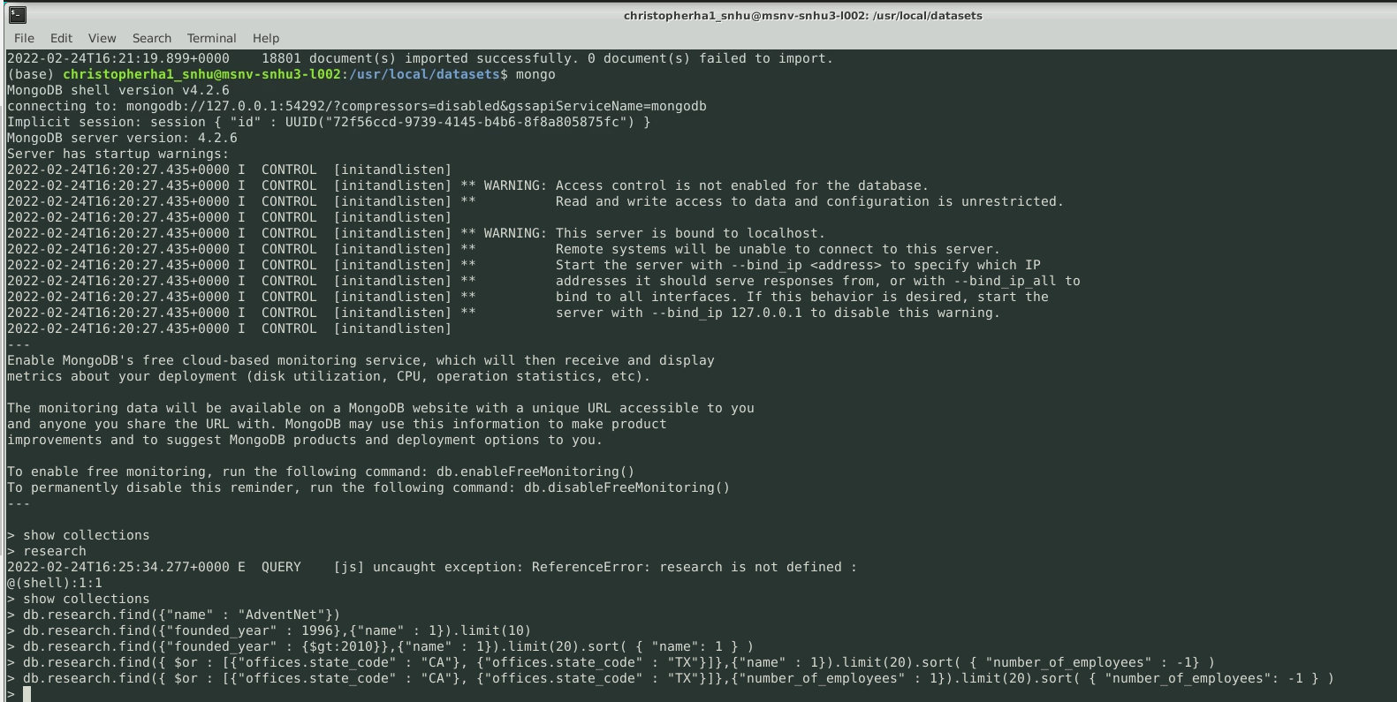

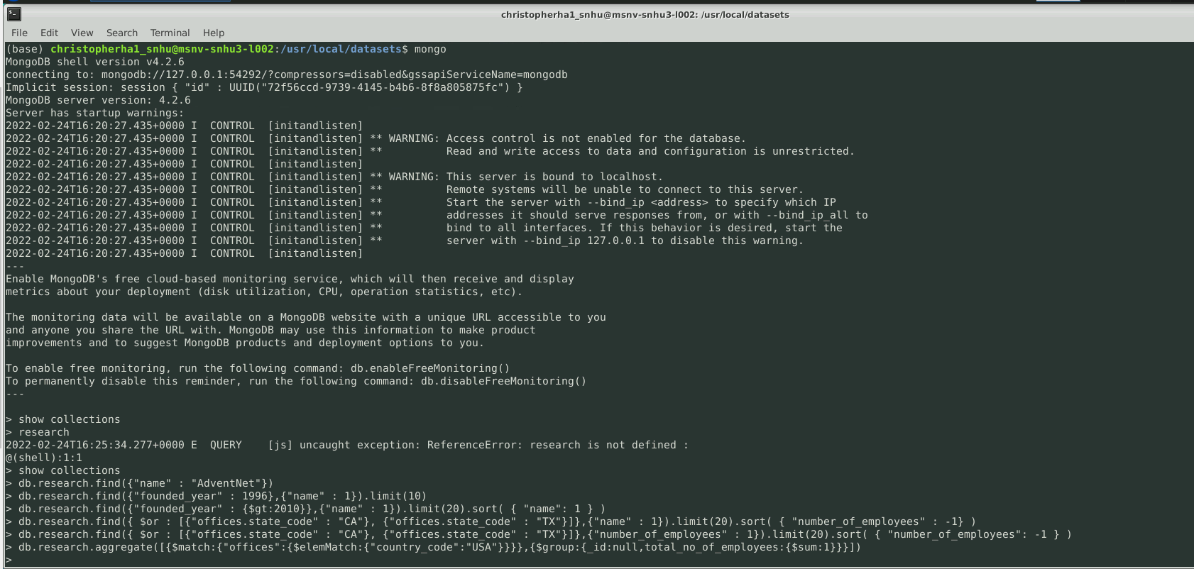





Q: How do you write programs that are maintainable, readable, and adaptable? Especially consider your work on the CRUD Python module from Project One, which you used to connect the dashboard widgets to the database in Project Two. What were the advantages of working in this way? How else could you use CRUD Python module in the future?

A: Maintainable code is hard to write. It should be in the form that is testable, readable, and easy to understand. Any of these are tricky to do. The code should be easy to read, there shouldn’t be any repeats, and add small things to make it more user friendly.

Q: How do you approach a problem as a computer scientist? Consider how you approached the database or dashboard requirements that Grazioso Salvare requested. How did your approach to this project differ from previous assignments in other courses? What techniques or strategies would you use in the future to create databases to mee other client requests?

A: I would approach a problem as a computer scientist by looking at what the problem was, what happed before the problem occurred. My approach was different in the project from other projects because this one we had to build everything and stay within the parameters of what the customer wanted.

Q: What do computer scientists do, and why does it matter? How would your work on this type of project help a company, like Grazioso Salvare, to do their work better?

A: A computer scientist uses technology to solve a range of different problems. The work that I would do to try to make a company run more efficiently would be to make sure that everything I worked on would be easy to find, easy to read and understand. I would also make sure that in my code I would put little widgets in that would make it more user friendly.